
OpenShift Container Platform 3.6
安装部署手册

作者 | 王健
版本 | V1.0
日期 | 2017.9.4
RHEL | Version 7.4
OpenShift | Version 3.6.173.0.5

目录
文档变更记录 4
1． 概述 4
1.1 版本信息 4
1.2 说明 4
2． 部署需求 4
3． 资源需求清单 5
4． 域名规划 6
5． 部署及验证过程 6
6.1 环境准备和验证 6
6.1.1 所有主机名配置 6
6.1.2 操作系统验证 6
6.1.3 创建yum源 7
6.2 部署OCP 3.6集群 8
6.2.1 所有OCP节点开启selinux 8
6.2.2 配置DNS服务器 8
6.2.3 控制台配置SSH到各节点的互信 11
6.2.4 登录infra01，配置ansible hosts 11
6.2.5 配置yum 13
6.2.6 控制台安装atomic-openshift-utils 14
6.2.7 分发yum配置到各节点 14
6.2.8 各节点安装软件 14
6.2.9 各节点安装docker 14
6.2.10 各节点配置docker 后端存储 14
6.2.11 安装docker-registry 15
6.2.12 修改image标签： 15
6.2.13 Push image到registry 16
6.2.14 执行ansible安装OCP 16
6.2.15 重启openshift master和node services命令 16
6.2.16 创建管理员用户 16
6.3 其他配置 17
6.3.1 增加VIP（10.214.171.200），作为lb01/lb02的虚拟IP（使用F5则跳过该步骤） 17
6.3.2 集群部署2个oserouter 18
6.3.3 Registry使用Glusterfs共享持久化存储 18
6.4 同步AD 组配置 21
6.4.1 配置LDAP SYNC 21
6.4.2 执行LDAP SYNC 22
6.5 集群验证 23

文档变更记录
变更时间 | 变更人 | 变更内容
2017-8-25 | 王健 | V1.0

概述
部署OCP3.6高可用集群，本文详细描述具体部署过程。

版本信息
OS | RHEL7.4
Openshift | v3.6.173.0.5
Docker | 1.12.6
Docker-distribution | 2.6.1
nfs | 1.3.0

说明
本文中所有IP和主机域名均为示例，实际部署时需替换成实际的值。

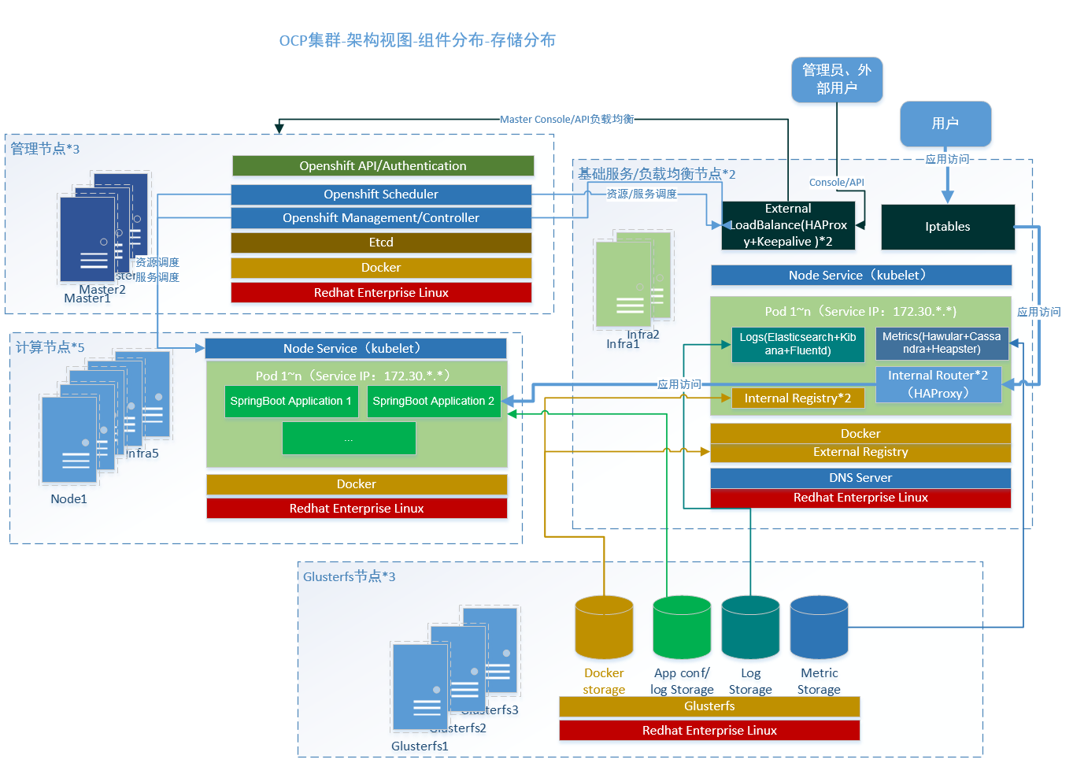

部署及验证过程

环境准备和验证

所有主机名配置
# hostnamectl set-hostname dev-master.ocp.csvw.com
# reboot

操作系统验证
本次部署所有节点的操作系统均为Red Hat Enterprise Linux Server release 7.4
可通过命令查看：
$ cat /etc/redhat-release

磁盘格式化、扩容
fdisk –l 查看磁盘分区情况

lvdisplay 查看磁盘占用

[root@trqypt4 media]# pvs
PV VG Fmt Attr PSize PFree
/dev/xvda3 rhel lvm2 a-- 71.51g 8.00m

给磁盘扩容：lvextend -L +51G /dev/rhel/root
使生效xfs_growfs /dev/rhel/root

创建yum源
登录yum源服务器
创建目录
mkdir -p /yum/ose

上传文件到该目录，目录结构
/yum/ose36
├── repodata
├── rhel-7-fast-datapath-rpms
│ └── Packages
├── rhel-7-server-extras-rpms
│ ├── Packages
│ └── repodata
├── rhel-7-server-ose-3.6-rpms
│ └── Packages
└── rhel-7-server-rpms
├── Packages
└── repodata
修改目录权限
chmot -R 755 /yum/*
安装httpd
#yum -y install httpd
配置httpd，
# vi /etc/httpd/conf/httpd.conf
…
Listen 81
…
#
DocumentRoot "/yum"

#
# Relax access to content within /var/www.
#
<Directory "/yum">
AllowOverride None
# Allow open access:
Require all granted
</Directory>

# Further relax access to the default document root:
<Directory "/yum">

重启httpd
#systemctl enable httpd
#systemctl restart httpd
web访问测试
http://<infra01-hostname>:81/ose36/

配置文件：
cat /etc/yum.repo.d/ose.repo
[server]
name=server
baseurl=http://10.1.14.150:81/repo/rhel-7-server-rpms
enabled=1
gpgcheck=0

[extra]
name=extra
baseurl=http://10.1.14.150:81/repo/rhel-7-server-extras-rpms
enabled=1
gpgcheck=0

[datapath]
name=datapath
baseurl=http://10.1.14.150:81/repo/rhel-7-fast-datapath-rpms
enabled=1
gpgcheck=0

[ose]
name=ose
baseurl=http://10.1.14.150:81/repo/rhel-7-server-ose-3.5-rpms
enabled=1
gpgcheck=0

createrepo -p -d -o ose ose

部署OCP 3.6集群

所有OCP节点开启selinux
设置SELINUX=enforcing，然后boot服务器
$ vi /etc/selinux/config
# This file controls the state of SELinux on the system.
# SELINUX= can take one of these three values:
# enforcing - SELinux security policy is enforced.
# permissive - SELinux prints warnings instead of enforcing.
# disabled - No SELinux policy is loaded.
SELINUX=enforcing
# SELINUXTYPE= can take one of three two values:
# targeted - Targeted processes are protected,
# minimum - Modification of targeted policy. Only selected processes are protected.
# mls - Multi Level Security protection.
SELINUXTYPE=targeted

配置DNS服务器

安装DNS服务
与DNS服务器上安装DNS服务软件包BIND。执行如下命令：
yum -y install bind* iptables-services;
systemctl enable named ;

修改配置
修改配置文件/etc/named.conf。命令如下：
cp /etc/named.conf /etc/named.conf.bak.$(date "+%Y%m%d%H%M%S");
sed -i s/"listen-on port 53 { 127.0.0.1; };"/"listen-on port 53 { any; };"/g /etc/named.conf;
sed -i s/"listen-on-v6 port 53 { ::1; };"/"listen-on port 53 { any; };"/g /etc/named.conf;
sed -i s/"allow-query { localhost; };"/"allow-query { any; };"/g /etc/named.conf;
sed -i '/rfc1912/i\zone "apps.example.com" IN { type master; file "dynamic/apps.example.com.db"; };' /etc/named.conf
sed -i '/rfc1912/i\zone "example.com" IN { type master; file "dynamic/example.com.db"; };' /etc/named.conf

创建域名数据库文件
在DNS服务器上创建域名数据库文件。需要注意subdomain的配置，本示例用的apps.ocp.will.com,需要后面定义ansible inventory的subdomain一致.命令如下：
文件1：
cat << EOF > /var/named/dynamic/ocp.will.com.db
\$ORIGIN .
\$TTL 1 ; 1 sec
ocp.will.com IN SOA dns.ocp.will.com. master.ocp.will.com. (
2011112904 ; serial
60 ; refresh
15 ; retry
1800 ; expire
10 ; minimum
)
NS dns.ocp.will.com.
MX 10 mail.ocp.will.com.
\$ORIGIN ocp.will.com.
dns A 10.122.7.80
master A 10.122.7.122
debug-node1 A 10.122.7.104
debug-infra A 10.122.7.84
debug-registry A 10.122.7.84
EOF
文件2：
cat << EOF > /var/named/dynamic/debugapps.ocp.csw.com.db
\$ORIGIN .
\$TTL 1 ; 1 sec
debugapps.ocp.csw.com IN SOA debug-dns.debugapps.ocp.csw.com. debug-master.debugapps.ocp.csw.com. (
2011112904 ; serial
60 ; refresh
15 ; retry
1800 ; expire
10 ; minimum
)
NS debug-dns.debugapps.ocp.csw.com.
MX 10 mail.debugapps.ocp.csw.com.
\$ORIGIN debugapps.ocp.csw.com.
* A 10.122.7.84
EOF

重启BIND服务
重启BIND服务，使修改的配置生效。
systemctl restart named;

配置iptables
修改iptables规则。命令如下：
cp /etc/sysconfig/iptables /etc/sysconfig/iptables.bak.$(date "+%Y%m%d%H%M%S");
sed -i '/.*--dport 22 -j ACCEPT.*/a\-A INPUT -p tcp -m state --state NEW -m tcp --dport 53 -j ACCEPT' /etc/sysconfig/iptables;
sed -i '/.*--dport 22 -j ACCEPT.*/a\-A INPUT -p udp -m state --state NEW -m udp --dport 53 -j ACCEPT' /etc/sysconfig/iptables;
sed -i '/.*--dport 22 -j ACCEPT.*/a\-A INPUT -p tcp -m state --state NEW -m tcp --dport 5000 -j ACCEPT' /etc/sysconfig/iptables;
sed -i '/.*--dport 22 -j ACCEPT.*/a\-A INPUT -p tcp -m state --state NEW -m tcp --dport 80 -j ACCEPT' /etc/sysconfig/iptables;

systemctl restart iptables;

配置DNS解析
在所有的节点上配置启用新搭建的DNS服务器进行域名解析。命令如下：
nmcli conn modify eth0 ipv4.dns 10.122.7.80;
systemctl restart Networkmanager;

测试DNS解析
nslookup test.debugapps.ocp.csw.com
debug-master.ocp.csw.com

控制台配置SSH到各节点的互信
在Infra01节点（作为控制台）上生成SSH所需之秘钥。命令如下，应答输入请直接输入回车。
ssh-keygen
在Infra01节点上配置 Infra01节点到各个节点（Masters，Nodes）的SSH主机互信。命令如下
for i in master0{1,2,3}.ocp.csvw.com node0{1,2}.ocp.csvw.com infra0{1,2}.ocp.csvw.com
do
echo $i
ssh-copy-id $i;
done;

登录infra01，配置ansible hosts
[root@dev-master ~]# cat /etc/ansible/hosts
[OSEv3:children]
masters
nodes
etcd
nfs

[OSEv3:vars]
ansible_ssh_user=root
deployment_type=openshift-enterprise
openshift_release=v3.6

# Enable cockpit
osm_use_cockpit=true
#
# Set cockpit plugins
osm_cockpit_plugins=['cockpit-kubernetes']

oreg_url=dev-registry.ocp.csvw.com:5000/openshift3/ose-${component}:${version}
openshift_docker_additional_registries=dev-registry.ocp.csvw.com:5000 ,172.30.0.1/16:5000
openshift_docker_insecure_registries=dev-registry.ocp.csvw.com:5000 ,172.30.0.1/16:5000
openshift_examples_modify_imagestreams=true

openshift_master_identity_providers=[{'name': 'htpasswd_auth', 'login': 'true', 'challenge':'true', 'kind': 'HTPasswdPasswordIdentityProvider', 'filename': '/etc/origin/master/htpasswd'}]

openshift_hosted_registry_selector="infra=true"

openshift_hosted_router_selector="router=true"

openshift_master_cluster_method=native
openshift_master_cluster_hostname=dev-master.ocp.csvw.com
openshift_master_cluster_public_hostname=dev-master.ocp.csvw.com

# default subdomain to use for exposed routes
openshift_master_default_subdomain=apps.ocp.csvw.com

openshift_node_kubelet_args={'pods-per-core': ['10'], 'max-pods':['60']}

openshift_metrics_install_metrics=true
openshift_hosted_metrics_deploy=true
openshift_hosted_metrics_public_url=https://hawkular-metrics.apps.ocp.csvw.com/hawkular/metrics
openshift_metrics_image_prefix=dev-registry.ocp.csvw.com:5000/openshift3/
openshift_metrics_image_version=3.6.0

openshift_hosted_logging_deploy=true
openshift_logging_image_prefix=dev-registry.ocp.csvw.com:5000/openshift3/
openshift_logging_image_version=3.6.0

# enable ntp on masters to ensure proper failover
openshift_clock_enabled=true

#Skip checking docker images & memory
#openshift_disable_check=docker_image_availability,memory_availability

# host group for masters
[masters]
dev-master.ocp.csvw.com

# host group for etcd
[etcd]
dev-master.ocp.csvw.com

# host group for nodes, includes region info
[nodes]
dev-master.ocp.csvw.com
dev-node1.ocp.csvw.com openshift_node_labels="{'region': 'primary', 'zone': 'default'}"
dev-node2.ocp.csvw.com openshift_node_labels="{'region': 'primary', 'zone': 'default'}"
dev-infra.ocp.csvw.com openshift_node_labels="{'region': 'infra', 'zone': 'default','infra': 'true','router': 'true',}"

[nfs]
dev-infra.ocp.csvw.com

修改playbook参数
如果是测试环境:内存、磁盘没有达到ocp最小要求（内存16GB，docker没有配置额外的device），需加上以下参数，避免安装过程CHECK point failed。
/usr/share/ansible/openshift-ansible/playbooks/byo/openshift-cluster/config.yml
最后一行加上
openshift_disable_check= “disk_availability,docker_image_availability,memory_availability,docker_storage”

配置yum
infra上增加repo文件
# cat /etc/yum.repos.d/ose.repo
[ose36]
name=ose36 - Media
baseurl=http://10.122.7.88/ose
gpgcheck=0
enabled=1

控制台安装atomic-openshift-utils
yum -y install atomic-openshift-utils

分发yum配置到各节点
ansible all -s -m copy -a "src=/etc/yum.repos.d/ ose.repo dest=/etc/yum.repos.d/ose.repo "

各节点安装软件
# yum -y install wget git net-tools bind-utils httpd-tools iptables-services bridge-utils nfs-utils bash-completion vim lrzsz unzip tree atomic-openshift-util;
# yum -y update;

各节点安装docker
# yum -y install docker;
# systemctl enable docker;

各节点配置docker 后端存储
注意：如果各节点使用/var默认文件系统作为docker后端存储，则不需要执行该步骤，docker默认使用/var/lib/docker路径
# systemctl stop docker;
# rm -rf /var/lib/docker
# echo "DEVS=/dev/sdb
VG=docker-vg
SETUP_LVM_THIN_POOL=yes"> /etc/sysconfig/docker-storage-setup;

# docker-storage-setup;
# systemctl start docker;
# lvs;

安装docker-registry
# sudo yum install docker-distribution
# 导入image
docker load -i ose3-images.tar.gz
docker load -i ose3-logging.tar.gz
docker load -i ose3-metrics.tar.gz
docker load -i ose3-registry-console.tar.gz
docker load -i ose3-service-catalog.tar.gz
docker load -i ose3-tomcat.tar.gz
docker load -i metrics-hawkular-metrics.v3.6.tar.gz
docker load -i openjdk18-openshift.tar

修改iptables
开放端口5000，协议tcp，增加如下记录到/etc/sysconfig/iptables
-A INPUT -p tcp -m state --state NEW -m tcp --dport 5000 -j ACCEPT
然后重启iptables服务器
systemctl restart iptables

修改image标签：
# docker images|grep access.redhat|awk '{print $1"/"$2}'|awk -F "/" '{print "docker tag "$1"/"$2"/"$3":"$4" registry01.ocp.wanda-group.net:5000/"$2"/"$3":"$4}'|sh

脚本示例：
docker images|grep latest|awk '{print "docker tag "$1":"$2" " $1":v3.6.173.0.5"}'|sh

镜像tags：
logging：
/etc/ansible/hosts参数
openshift_logging_image_version=3.6.0
tags:
openshift3/logging-curator:3.6.0
​
openshift3/logging-elasticsearch:3.6.0
​
openshift3/logging-elasticsearch:3.6.0
​
openshift3/logging-fluentd:3.6.0
​
openshift3/logging-kibana:3.6.0
​
openshift3/logging-auth-proxy:3.6.0
metrics：
/etc/ansible/hosts参数
openshift_metrics_image_version=3.6.0
tags:
openshift3/metrics-cassandra:3.6.0
​
openshift3/metrics-hawkular-metrics:3.6.0
​
openshift3/metrics-heapster:3.6.0
openshift3/metrics-deployer:3.6.0
OSE core and Service-Catalog
openshift3/ose-service-catalog:v3.6.173.0.5
openshift3/ose-ansible-service-broker:v3.6.173.0.5
openshift3/ose-deployer:v3.6.173.0.5
openshift3/ose-recycler:v3.6.173.0.5
openshift3/ose-haproxy-router:v3.6.173.0.5
openshift3/ose-sti-builder:v3.6.173.0.5
openshift3/ose-docker-builder:v3.6.173.0.5
openshift3/ose-docker-registry:v3.6.173.0.5
openshift3/ose-pod:v3.6.173.0.5
Registry-console
openshift3/registry-console:v3.6

Push image到registry
# docker images|grep dev-registry.ocp.csvw.com:5000|awk '{print "docker push " $1":"$2}'|sh

时间同步
ansible all -a "yum install -y chrony"
ansible all -a "systemctl enable chronyd.service"
ansible all -a "systemctl start chronyd.service"
scp /etc/chrony.conf root@node.ocp.will.com:/etc/
ansible all -a "systemctl restart chronyd.service"
查看时间同步源：# chronyc sources -v

执行ansible安装OCP
# ansible-playbook /usr/share/ansible/openshift-ansible/playbooks/byo/config.yml

重启openshift master和node services命令
$ ansible masters -m "command" -a "systemctl restart atomic-openshift-master-api.service "
$ ansible masters -m "command" -a "systemctl restart atomic-openshift-master-controllers.service "
$ ansible nodes -m "command" -a "systemctl restart atomic-openshift-node.service "

创建管理员用户
3台master节点
ansible masters -a " yum -y install httpd-tools "
ansible masters -a " htpasswd -cb /etc/origin/master/htpasswd admin welcome1"

登录其中一台master，给admin赋予管理员权限
oadm policy add-role-to-user admin admin

创建一个cluster admin
3台master上
ansible masters -a " htpasswd -b /etc/origin/master/htpasswd cluster-admin welcome1"
其中一台master上
oadm policy add-role-to-user cluster-admin cluster-admin

其他配置

增加VIP（10.214.171.200），作为lb01/lb02的虚拟IP（使用F5则跳过该步骤）
在lb01和lb02安装keepalived
#yum install -y keepalived
#mv keepalived.conf keepalived.conf.bak
#vi keepalived.conf
内容如下：
! Configuration File for keepalived

vrrp_script chk_http_port {
script "/etc/keepalived/check_haproxy.sh"
interval 2
weight 2

global_defs {
router_id LVS_DEVEL
}
vrrp_instance VI_1 {
state MASTER #infra02上改为BACKUP，infra01作为MATER
interface ens33
virtual_router_id 51
priority 150 #infra02上改为120
advert_int 1
authentication {
auth_type PASS
auth_pass 1111
}

track_script {
chk_http_port
}

virtual_ipaddress {
10.214.171.200
}
}
}

#vi check_haproxy.sh
创建check_haproxy.sh文件如下
#!/bin/bash
A=`ps -C haproxy --no-header |wc -l`
if [ $A -eq 0 ];then
/usr/local/haproxy/sbin/haproxy -f /usr/local/haproxy/conf/haproxy.cfg
sleep 3
if [ `ps -C haproxy --no-header |wc -l` -eq 0 ];then
/etc/init.d/keepalived stop
fi
fi

#systemctl restart keepalived
#systemctl enable keepalived

集群部署2个oserouter
OCP3.4默认已结部署router，replics=3,#oc edit dc router修改为2即可

Registry使用Glusterfs共享持久化存储
步骤：部署Glusterfs集群→创建Glusterfs卷→创建service&ndpoint→创建pv,pvc→挂载卷到Registry Deployment Configuration

部署Glusterfs集群和创建Gluster卷参考：6.2.2章节
三台gluster服务器上做如下操作：
创建lv
lvcreate -n inter_registry_lv01 -L 100G gluster_vg01
mkfs.xfs -i size=512 /dev/gluster_vg01/inter_registry_lv01
挂载lv到/data/brick2
mkdir -p /data/brick2
写在开机自启
# cat /etc/fstab
/dev/mapper/gluster_vg01-inter_registry_lv01 /data/brick2 xfs defaults 0 0
# mount -a
# df –h
分配gluster卷gv02
在三台gluster服务器上：
# mkdir -p /data/brick2/gv02
在一台gluster服务器创建replicas卷
gluster volume create gv02 replica 3 gluster01.ocp.wanda-group.net:/data/brick2/gv02 gluster02.ocp.wanda-group.net:/data/brick2/gv02
gluster03.ocp.wanda-group.net:/data/brick2/gv02
在一台gluster服务器上启动

gluster volume start gv02

在一台master节点做如下操作：
想创建service配置文件：gluster-service.yaml
[root@ctum2-vmo-214171011 ~]# vi gluster-service.yaml
apiVersion: v1
kind: Service
metadata:
name: glusterfs-cluster
spec:
ports:
- port: 1
创建endpoint配置文件：gluster-endpoints.yaml
[root@ctum2-vmo-214171011 ~]# more gluster-endpoints.yaml
apiVersion: v1
kind: Endpoints
metadata:
name: glusterfs-cluster
subsets:
- addresses:
- ip: 10.214.171.21
ports:
- port: 1
创建endpoint和service：
# oc create -f gluster-endpoints.yaml
# oc create -f gluster-service.yaml
创建pv配置文件：gluster-pv.yaml & 创建PV
[root@ctum2-vmo-214171011 ~]# more registry01-pv30-100Gi.yaml
apiVersion: v1
kind: PersistentVolume
metadata:
name: registry01-pv30
spec:
capacity:
storage: 100Gi
accessModes:
- ReadWriteMany
glusterfs:
endpoints: glusterfs-cluster
path: gv30
readOnly: false
persistentVolumeReclaimPolicy: Retain

[root@ctum2-vmo-214171011 ~]# oc create -f registry01-pv30-100Gi.yaml
说明：
PV配置当中的两个参数："capacity": "storage"和"accessModes"的值需与应用模板当中的pvc的定义一致，该PV才能被该模板的PVC申请
创建PVC配置文件&创建pvc
[root@ctum2-vmo-214171011 ~]# more registry01-claim.yaml
apiVersion: v1
kind: PersistentVolumeClaim
metadata:
name: registry01-claim
spec:
accessModes:
- ReadWriteMany
resources:
requests:
storage: 100Gi
[root@ctum2-vmo-214171011 ~]# oc create -f registry01-claim.yaml -n default

挂载卷到Registry
[root@ctum2-vmo-214171011 ~]# oc volume dc docker-registry --add --overwrite -t persistentVolumeClaim --claim-name=registry01-claim --name=registry-storage

同步AD 组配置
完整示例参考OpenShift_Container_Platform-3.4-Installation_and_Configuration-en-US.pdf的CHAPTER 13. SYNCING GROUPS WITH LDAP

配置LDAP SYNC
在同步之前需创建一个sync配置文件，该文件包含内容：
- LDAP SERVER的连接信息
- 配置选项依赖于LDAP SERVER的shcema
该配置文件可以定义LDAP GROUPS与OCP GROUPS的映射关系。

LDAP Client配置示例
url: ldap://10.0.0.0:389
bindDN: cn=admin,dc=example,dc=com
bindPassword: password
insecure: true
ca: my-ldap-ca-bundle.crt

LDAP 查询配置示例
baseDN: ou=users,dc=example,dc=com
scope: sub
derefAliases: never
timeout: 0
filter: (objectClass=inetOrgPerson)
pageSize: 0

定义映射关系
groupUIDNameMapping:
"cn=group1,ou=groups,dc=example,dc=com": firstgroup
"cn=group2,ou=groups,dc=example,dc=com": secondgroup
"cn=group3,ou=groups,dc=example,dc=com": thirdgroup

执行LDAP SYNC
完成配置文件后，可以执行同步操作

同步所有
$ oadm groups sync --sync-config=config.yaml --confirm

同步配置文件定义的组
$ oadm groups sync --type=openshift --sync-config=config.yaml --confirm

可以定义whitelist、blacklist
$ oadm groups sync --whitelist=<whitelist_file> \
--sync-config=config.yaml \
--confirm
$ oadm groups sync --blacklist=<blacklist_file> \
--sync-config=config.yaml \
--confirm
$ oadm groups sync <group_unique_identifier> \
--sync-config=config.yaml \
--confirm
$ oadm groups sync <group_unique_identifier> \
--whitelist=<whitelist_file> \
--blacklist=<blacklist_file> \
--sync-config=config.yaml \
--confirm
$ oadm groups sync --type=openshift \
--whitelist=<whitelist_file> \
--sync-config=

删除组（该组在OCP存在，但是LDAP里面不存在）
$ oadm groups prune --sync-config=config.yaml --confirm

集群验证
分别登录master 1~3节点验证

登录ocp cli
# oc login -u system:admin
Logged into "https://openshift-cluster.wanda-group.net:8443" as "system:admin" using existing credentials.

You have access to the following projects and can switch between them with 'oc project <projectname>':
* default

查看版本信息
[root@ctum2-vmo-214171011 ~]# oc version
oc v3.4.1.10
kubernetes v1.4.0+776c994
features: Basic-Auth GSSAPI Kerberos SPNEGO

Server https://openshift-cluster.wanda-group.net:8443
openshift v3.4.1.10
kubernetes v1.4.0+776c994

查看状态
# oc status
In project default on server https://openshift-cluster.wanda-group.net:8443

https://docker-registry-default.router.default.svc.cluster.local (passthrough) to pod port 5000-tcp (svc/docker-registry)
http://registry-route-default.apps.wanda-group.net to pod port 5000-tcp
dc/docker-registry deploys docker.io/openshift3/ose-docker-registry:v3.4.1.10
deployment #9 deployed 6 days ago - 2 pods
deployment #8 deployed 6 days ago
deployment #7 failed 6 days ago: config change

svc/glusterfs-cluster - 172.30.139.203:1

svc/kubernetes - 172.30.0.1 ports 443, 53->8053, 53->8053

https://registry-console.apps.wanda-group.net (passthrough) to pod port registry-console (svc/registry-console)
dc/registry-console deploys registry01.wanda-group.net:5000/openshift3/registry-console:3.4
deployment #3 deployed 7 days ago - 1 pod
deployment #2 deployed 7 days ago
deployment #1 deployed 7 days ago

svc/router - 172.30.203.195 ports 80, 443, 1936
dc/router deploys docker.io/openshift3/ose-haproxy-router:v3.4.1.10
deployment #5 deployed 4 weeks ago - 1 pod
deployment #4 failed 4 weeks ago: cancelled by the user
deployment #3 failed 4 weeks ago: cancelled by the user

- warnings identified, use 'oc status -v' to see details.

查看节点状态
[root@dev-master opt]# oc get node
NAME STATUS AGE VERSION
dev-infra.ocp.csvw.com Ready 1d v1.6.1+5115d708d7
dev-master.ocp.csvw.com Ready,SchedulingDisabled 1d v1.6.1+5115d708d7
dev-node1.ocp.csvw.com Ready 1d v1.6.1+5115d708d7
dev-node2.ocp.csvw.com Ready 1d v1.6.1+5115d708d7

6.6 问题汇总：

6.6.1 ssh 无法登陆
150 机器ssh 无法登陆到其他机器，报错如下:
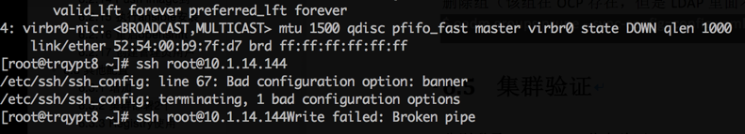

现场解决方案：
vi /etc/ssh/ssh_config 注释掉Banner
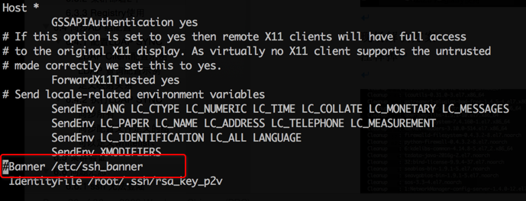

6.6.2 启动分区磁盘损坏

6.6.2.1主要现象：
- yum update cleanup 不过

安装完yum源，yum update 过程中 cleanup 卡住，近一个小时不过后强制退出
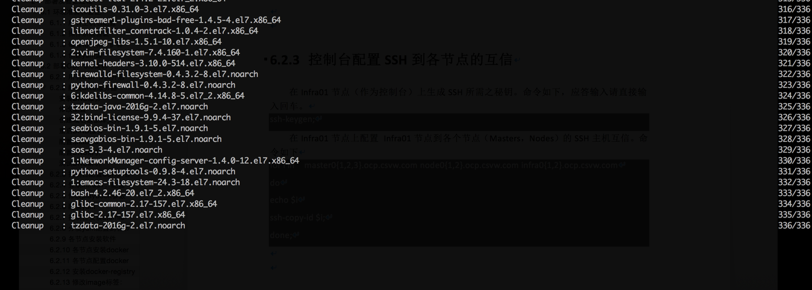

- 安装 atomic-openshift-utils 报错
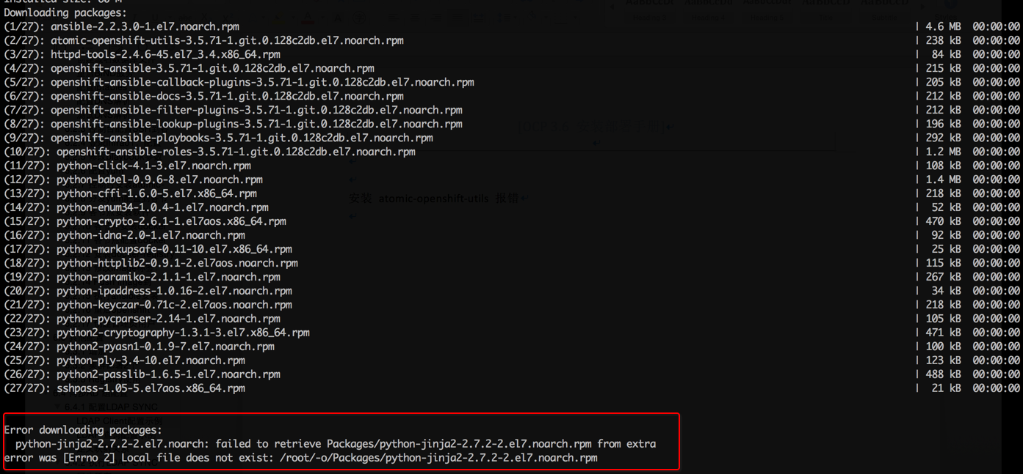

- yum update kernel
升级内核后，vi /boot/grub2/grub.cfg 无法编辑

系统做过安全加固，/boot/grub2/ 目录没有写权限

6.6.2.2 现场解决方案
检查/boot目录权限
ll -d /boot

修改/boot目录权限
chmod -Rf 755 /boot
ll /boot -d
ll /boot/

备份/boot
mkdir /boot.bak
cp -Rf /boot/* /boot.bak/

修复/boot分区
umount /boot
xfs_repair /dev/xvda1
mount -a
df –hT

检查当前kernel版本
uname -a
rpm -qa|grep kernel

升级kernel
yum update kernel

查看grub.cfg
cat /boot/grub2/grub.cfg

重启服务器
reboot
uname -a
cat /boot/grub2/grub.cfg

6.6.3 ssh HOSTNAME 无法设置
使用 hostnamectl set-hostname aaa.test.demo.com 后重启机器失效，检查发现是由于cloud-init 服务自动把hostname 配置刷到初始值。

现场解决方案：

将 /etc/cloud/cloud.cfg 文件中hostname 选项删除，使其开启不初始化hostname

6.6.4 DNS 设置失效
手动修改DNS:
nmcli connection modify eth0 ipv4.dns 10.1.13.188
nmcli connection modify eth0 ipv4.ignore-auto-dns yes
systemctl restart NetworkManager
cat /etc/resolv.conf
resolv.conf文件内容
#Generated by NetworkManager
search testdomain.com.cn
nameserver 10.1.13.188

6.6.5 Docker 存储
Docker DeviceMapper存储，默认使用/var/lib/docker 空间
如果使用docker-storage-setup 命令，则可以给docker 分配另外的磁盘分区或者逻辑卷
如果客户机器没有额外的存储，要修改Docker 存储为DeviceMapper

cat /etc/docker/deamon.json
{"storage-driver": "devicemapper"}

否则，安装包会利用主机上没有使用的卷创建一个 docker-pool 的逻辑卷，有可能导致磁盘不够

3. CentOS 7.4 安装ocp3.6 问题

3.1 iptables 包冲突；
解决方案：
rpm –aq | grep iptables
yum remove iptables

  - docker load 报错
devicemapper: Error running deviceCreate (createSnapDevice) dm_task_run failed
换了太机器问题解决, 可尝试
http://blog.csdn.net/u012948976/article/details/51763041

  - 安装报错

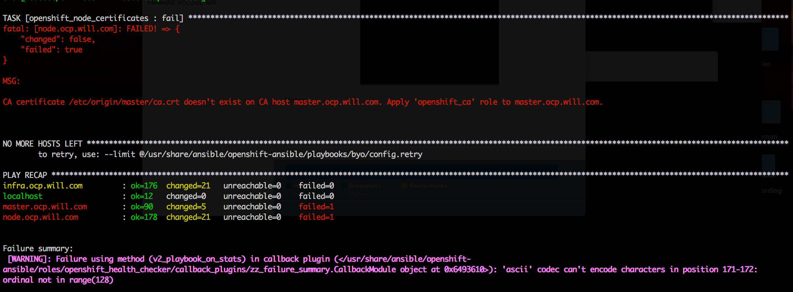

docker-storage-setup 磁盘分配大小如何设置

